David Merrick

10/8/12

Lab 3 Prelab

1. **What is the stack pointer?** The stack is primarily used for storing temporary data, including local variables. The stack pointer is a register that always points to the top of the stack. It is initialized with: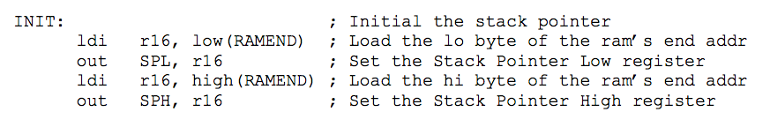
   1. First, the low byte of the final memory address for the stack is loaded and set as the stack pointer low register. Then, the high byte of the memory address of the stack is loaded and set as the stack pointer high register.
2. **What does the AVR instruction LPM do and how do you use it?** LPM is short for “Load Program Memory.” It loads one byte pointed to by the Z-register into the specified destination register. It is used in one of three ways: “LPM,” which implies R0 as the destination register, “LPM Rd, Z,” which copies Z to the register specified by Rd, and “LPM Rd, Z+,” which copies Z to the specified register and increments Z. Pseudocode: “LPM r4, Z.” This copies Z to register 4.
3. Inside this definition file are registers that are mapped to descriptive variables. This is advantageous because it saves a programmer the headache of having to look up the address of a certain register every time he or she wants to call it and can instead call the variable name. To include the file, just write ‘.include "m128def.inc".’